Chapter 13 Monopoly

13.1 Monopoly and How It Arises

1) An exclusive right granted to a firm to supply a good or service is
A) a licence.
B) a patent.
C) a public franchise.
D) the essential characteristic of natural monopoly.
E) an economy of scale.
Answer: C
Diff: 1 Type: MC
Topic: Monopoly and How It Arises

2) A natural monopoly exists when
A) the government protects the firm by granting an exclusive franchise.
B) production can take place with constant returns to scale.
C) there are no rivals in the market.
D) one firm can supply the entire market at a lower cost than two or more firms.
E) the average total cost curve is upward sloping.
Answer: D
Diff: 1 Type: MC
Topic: Monopoly and How It Arises

3) In a natural monopoly, the long-run average cost curve
A) is downward sloping in the relevant range of output levels.
B) is horizontal in the relevant range of output levels.
C) is upward sloping in the relevant range of output levels.
D) may be either upward sloping or downward sloping in the relevant range of output levels.
E) lies below the marginal cost curve.
Answer: A
Diff: 2 Type: MC
Topic: Monopoly and How It Arises

4) Which one of the following is an example of a natural barrier to entry of new firms into an industry?
A) licensing of professions
B) economies of scale
C) issuing a patent
D) a public franchise
E) all of the above
Answer: B
Diff: 2 Type: MC
Topic: Monopoly and How It Arises
Source: Study Guide
5) To prevent monopoly from arising, there must be
A) a single supplier of a good in the market.
B) no close substitutes for the good.
C) barriers preventing entry of other firms.
D) freedom of entry into the market.
E) economies of scale.
Answer: D
Diff: 2 Type: MC
Topic: Monopoly and How It Arises

6) Suppose in an industry a firm realizes economies of scale over the entire length of its LRAC curve. In this situation, the firm is
A) a natural monopoly.
B) a fixed-cost monopoly.
C) an output-discriminating monopoly.
D) a perfect-price discriminating monopoly.
E) a constant total variable cost monopoly.
Answer: A
Diff: 2 Type: MC
Topic: Monopoly and How It Arises

7) Which of the following is least likely to be a natural monopoly?
A) subway services
B) electric utilities
C) water and sewer services
D) taxicab service
E) cable television services
Answer: D
Diff: 2 Type: MC
Topic: Monopoly and How It Arises

8) A single-price monopoly is a firm that ________ each unit of its output ________. A ________ monopoly sells different units of a good or service for different prices.
A) produces; at a constant cost; discriminatory
B) must sell; for the same price to all its customers; price-discriminating
C) produces; at a constant cost; price-discriminating
D) must sell; for the same price to all its customers; discriminatory
E) must sell; at the same price as a perfectly competitive firm; price-discriminating
Answer: B
Diff: 2 Type: MC
Topic: Monopoly and How It Arises
Source: MyEconLab
9) Canada Post has a monopoly on residential mail delivery. Pfizer Inc. makes LIPITOR, a prescription drug that lowers cholesterol. Rogers Communications is the sole provider of cable television service in some parts of Ontario. The monopolies which are legal monopolies are ________.
A) only Pfizer
B) Canada Post, Pfizer, and Rogers Communications
C) Canada Post and Pfizer
D) only Canada Post
E) none of the above
Answer: C
Diff: 2 Type: MC
Topic: Monopoly and How It Arises
Source: MyEconLab

10) Canada Post has a monopoly on residential mail delivery. Pfizer Inc. makes LIPITOR, a prescription drug that lowers cholesterol. Rogers Communications is the sole provider of cable television service in some parts of Ontario. The monopolies which profit from price discrimination are ________.
A) Canada Post and Rogers Communications
B) only Pfizer
C) only Canada Post
D) all three monopolies
E) none of the above
Answer: D
Diff: 2 Type: MC
Topic: Monopoly and How It Arises
Source: MyEconLab

11) A monopoly arises for two key reasons, which are ________.
A) barriers to entry and no close substitutes
B) franchises and barriers to entry
C) barriers to entry and close substitutes
D) close substitutes and no barriers to entry
E) natural and legal
Answer: A
Type: MC
Topic: Monopoly and How It Arises
Skill: Recognition
AACSB: Reflective Thinking
12) A monopoly is a market with a single firm that
A) produces a good or service for which no close substitute exists and which is protected by a barrier that prevents other firms from selling that good or service.
B) purchases its factors of production from only one supplier because of a barrier preventing it from buying from other suppliers.
C) produces a good or service for which no close substitute exists and that sells all its output to one buyer because there is barrier preventing other buyers from purchasing the good or service.
D) cannot control the price it sets for its good or service because there is barrier that prevents the firm from changing the price.
E) produces its good or service using labour from a single source, which is usually a union.
Answer: A
Type: MC
Topic: Monopoly and How It Arises
Skill: Recognition
AACSB: Reflective Thinking

13) Firms that can price discriminate between customers do so to ________.
A) increase consumer surplus
B) increase employment
C) increase economic profit
D) decrease the quantity they produce
E) increase producer surplus and deadweight loss
Answer: C
Type: MC
Topic: Monopoly and How It Arises
Skill: Recognition
AACSB: Reflective Thinking

14) Which one of the following is most likely to be a natural monopoly?
A) sandwich shops
B) printing services
C) welding services
D) automotive service
E) electric utilities
Answer: E
Diff: 1 Type: MC
Topic: Monopoly Regulation

15) When Dominant Pizza is willing to sell a pizza to a student who lives on-campus at a lower price than it sells the identical pizza to a student who lives a block away from the campus, the pizza firm is
A) implementing unfair pricing practices.
B) incurring a loss on on-campus sales.
C) eliminating all competition.
D) located close to the campus.
E) practising price discrimination.
Answer: E
Type: MC
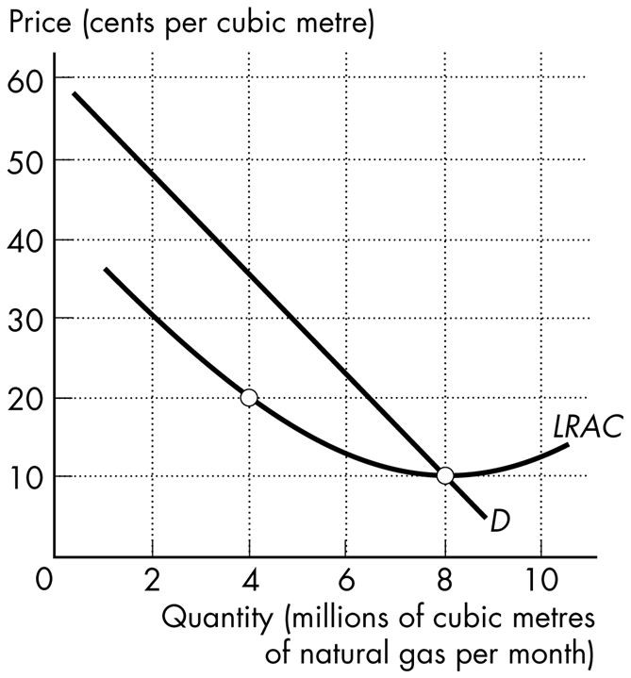

Figure 13.1.1

16) Refer to Figure 13.1.1. The quantity demanded by the market is 8 million cubic metres a month. This market is
A) a legal monopoly.
B) served by a perfect price discriminating monopoly.
C) served by many firms each making an economic profit.
D) served by many firms each incurring an economic loss.
E) a natural monopoly.
Answer: E
Type: MC
13.2 A Single-Price Monopoly's Output and Price Decision

Use the figure below to answer the following question.

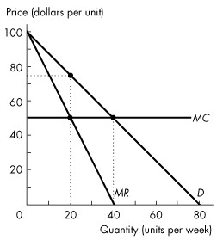
Figure 13.2.1

1) Refer to Figure 13.2.1. This single-price monopoly produces ________ units per day and charges a price of $________ per unit.
A) zero; 0
B) 20; 75
C) 40; 50
D) 20; 50
E) 20; 20
Answer: B
Diff: 2 Type: MC
Topic: A Single-Price Monopoly's Output and Price Decision

2) To increase sales from 7 units to 8 units, a single-price monopolist must drop the price from $7 per unit to $6 per unit. What is marginal revenue in this range?
A) $48
B) $6
C) $1
D) -$1
E) None of the above.
Answer: D
Diff: 2 Type: MC
Topic: A Single-Price Monopoly's Output and Price Decision
Source: Study Guide
Use the figure below to answer the following questions.

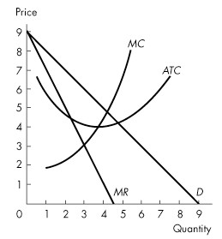
Figure 13.2.2

3) For the single-price monopoly shown in Figure 13.2.2, when profit is maximized, quantity is
A) 3 and price is $3.
B) 3 and price is $6.
C) 4 and price is $4.
D) 4 and price is $5.
E) 5 and price is $4.
Answer: B
Diff: 2 Type: MC
Topic: A Single-Price Monopoly's Output and Price Decision
Source: Study Guide

4) Refer to Figure 13.2.2. If the single-price monopoly shown in Figure 13.2.2 is maximizing profit, what is total economic profit?
A) $3
B) $4
C) $6
D) $9
E) None of the above.
Answer: C
Diff: 2 Type: MC
Topic: A Single-Price Monopoly's Output and Price Decision
Source: Study Guide
5) If a profit-maximizing monopoly is producing an output at which marginal cost exceeds marginal revenue, it
A) should raise price and decrease output.
B) should lower price and increase output.
C) should lower price and decrease output.
D) is incurring an economic loss.
E) is maximizing profit.
Answer: A
Diff: 2 Type: MC
Topic: A Single-Price Monopoly's Output and Price Decision
Source: Study Guide

Use the figure below to answer the following questions.

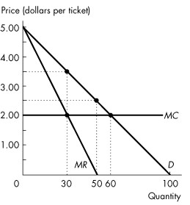
Figure 13.2.3

6) Refer to Figure 13.2.3. Assume this firm is a single-price monopoly. What is the profit-maximizing price to charge for the tickets?
A) $5.00
B) $4.00
C) $3.00
D) $2.00
E) $3.50
Answer: E
Diff: 2 Type: MC
Topic: A Single-Price Monopoly's Output and Price Decision
7) Refer to Figure 13.2.3. Assume this firm is a single-price monopoly. How many tickets does this monopolist sell to maximize economic profit?
A) 20 tickets
B) 30 tickets
C) 50 tickets
D) 60 tickets
E) 100 tickets
Answer: B
Diff: 2 Type: MC
Topic: A Single-Price Monopoly's Output and Price Decision

Use the figure below to answer the following question.

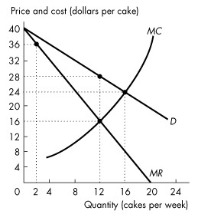
Figure 13.2.4

8) Refer to Figure 13.2.4. Grannie's is the only cake bakery on Coastal Island. The graph shows Grannie's demand curve, marginal revenue curve, and marginal cost curve. Grannie's profit-maximizing price is ________ a cake and its profit-maximizing output is ________ cakes a week.
A) $28; 12
B) $16; 12
C) $36; 2
D) $16; 24
E) $24; 16
Answer: A
Diff: 2 Type: MC
Topic: A Single-Price Monopoly's Output and Price Decision
Source: MyEconLab
9) A monopoly ________ make positive economic profit in the long run because ________.
A) can; barriers to entry prevent other firms from entering the market and sharing the profit
B) cannot; eventually demand will decrease and prices will fall
C) cannot; other firms will enter the market until all firms are making zero economic profit
D) can; new technology constantly lowers costs for the monopoly firm and for its competitors
E) can; demand constantly increases and price constantly rises
Answer: A
Diff: 2 Type: MC
Topic: A Single-Price Monopoly's Output and Price Decision
Source: MyEconLab

Use the table below to answer the following question.

Table 13.2.1

Price  (dollars per bottle) | Quantity Demanded  (bottles per hour)
10  8  6  4  2  0 | 0  1  2  3  4  5

10) Refer to Table 13.2.1. Minnie's Mineral Springs, a single-price monopoly, faces the market demand schedule given in the table. Minnie will not produce a quantity at which the market demand for water is inelastic because when demand is inelastic she can ________ the quantity produced, which ________.
A) increase; increases total revenue, decreases total cost, and increases economic profit
B) increase; increases total revenue and increases total cost, but the increase in total cost is less than the increase in total revenue
C) decrease; increases total revenue, decreases total cost, and increases economic profit
D) decrease; decreases total revenue and decreases total cost, but the decrease in total cost is less than the decrease in total revenue
E) decrease; increases total revenue, does not change total cost, and increases economic profit
Answer: C
Diff: 2 Type: MC
Topic: A Single-Price Monopoly's Output and Price Decision
Source: MyEconLab
11) A single-price monopolist's demand curve
A) is its marginal revenue curve.
B) shows that demand for the good is perfectly elastic.
C) is the same as the market demand curve.
D) shows that demand for the good is perfectly inelastic.
E) is horizontal.
Answer: C
Type: MC
Topic: A Single-Price Monopoly's Output and Price Decision
Skill: Recognition
AACSB: Reflective Thinking

12) For a single-price monopoly, the demand curve is
A) below the marginal revenue curve.
B) the same as the marginal revenue curve.
C) above the marginal revenue curve.
D) the same as the total revenue curve.
E) below the average total cost curve.
Answer: C
Type: MC
Topic: A Single-Price Monopoly's Output and Price Decision
Skill: Recognition
AACSB: Reflective Thinking

13) The marginal revenue curve for a single-price monopoly
A) is below its demand curve.
B) is the same as the demand curve.
C) lies above its demand curve.
D) is horizontal.
E) has a slope equal to the slope of the demand curve.
Answer: A
Type: MC
Topic: A Single-Price Monopoly's Output and Price Decision
Skill: Recognition
AACSB: Reflective Thinking

14) If marginal revenue equals zero, then demand at this level of output is
A) perfectly inelastic.
B) inelastic.
C) unit elastic.
D) elastic.
E) perfectly elastic.
Answer: C
Type: MC
Topic: A Single-Price Monopoly's Output and Price Decision
Skill: Conceptual
AACSB: Reflective Thinking
15) If the demand for its good or service is elastic, a monopoly's
A) total revenue is unchanged when the firm lowers its price.
B) total revenue decreases when the firm lowers its price.
C) marginal revenue is positive.
D) marginal revenue is zero.
E) marginal revenue is negative.
Answer: C
Type: MC
Topic: A Single-Price Monopoly's Output and Price Decision
Skill: Conceptual
AACSB: Reflective Thinking

16) If the demand for its good or service is inelastic, a monopoly's
A) total revenue increases when the firm lowers its price.
B) total revenue is unchanged when the firm lowers its price.
C) marginal revenue is negative.
D) marginal revenue is equal to zero.
E) marginal revenue is positive.
Answer: C
Type: MC
Topic: A Single-Price Monopoly's Output and Price Decision
Skill: Conceptual
AACSB: Reflective Thinking

17) A monopoly
A) faces a perfectly elastic demand.
B) ignores the demand curve because it is the only seller.
C) can raise the price it charges only if it decreases the quantity that it sells.
D) can raise the price it charges only if it increases the quantity that it sells.
E) faces a perfectly inelastic demand.
Answer: C
Type: MC

18) A single-price monopolist
A) maximizes economic profit by producing the quantity at which marginal revenue equals marginal cost.
B) maximizes economic profit by producing the quantity at which marginal revenue equals average total cost.
C) can increase the price and the quantity sold simultaneously.
D) is not restricted by the law of demand.
E) can sell as much as it wants at a given price because it is the only seller.
Answer: A
Type: MC
13.3 Single-Price Monopoly and Competition Compared

Use the figure below to answer the following questions.

Figure 13.3.1

1) Refer to Figure 13.3.1. If this market were perfectly competitive, the output level would exceed the single-price monopoly output level by
A) 20 units.
B) 40 units.
C) 60 units.
D) zero. The perfectly competitive firm and the single-price monopoly produce the same quantity because marginal cost is constant.
E) 30 units.
Answer: A
Diff: 3 Type: MC
Topic: Single-Price Monopoly and Competition Compared

2) Refer to Figure 13.3.1. The efficient quantity is
A) 20 units.
B) 40 units.
C) 60 units.
D) 80 units.
E) zero units.
Answer: B
Diff: 2 Type: MC
Topic: Single-Price Monopoly and Competition Compared
3) Refer to Figure 13.3.1. If this market is a single-price monopoly, then
A) it is efficient because the monopoly is maximizing economic profit.
B) price is equal to marginal cost and the outcome is efficient.
C) price is less than marginal cost, and consumer surplus is less than in a perfectly competitive market.
D) price is greater than the marginal cost and the outcome is inefficient.
E) the outcome is inefficient because the monopoly's costs are too high.
Answer: D
Diff: 2 Type: MC
Topic: Single-Price Monopoly and Competition Compared

4) The pursuit of wealth by capturing economic rent
A) is rent seeking.
B) is illegal in Canada.
C) is price discrimination.
D) creates a legal monopoly.
E) creates a natural monopoly.
Answer: A
Diff: 1 Type: MC
Topic: Single-Price Monopoly and Competition Compared
Use the figure below to answer the following questions.

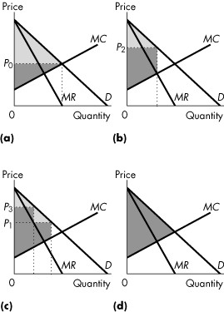

Figure 13.3.2

5) Consider Figure 13.3.2. Consider a perfectly competitive market. If the light grey area shows the consumer surplus, and the dark grey area shows the producer surplus, which graph correctly represents this market?
A) (a)
B) (b)
C) (c)
D) (d)
E) (b) and (d)
Answer: A
Diff: 3 Type: MC
Topic: Single-Price Monopoly and Competition Compared

6) Consider Figure 13.3.2. Consider a single-price monopoly. If the light grey area shows the consumer surplus, and the dark grey area shows the producer surplus, which graph correctly represents this firm?
A) (a)
B) (b)
C) (c)
D) (d)
E) (b) and (c)
Answer: B
Diff: 3 Type: MC
Topic: Single-Price Monopoly and Competition Compared
7) Taking competitive rent seeking activity into account, the social cost of monopoly is equal to the
A) deadweight loss from monopoly.
B) monopoly's producer surplus.
C) deadweight loss plus the monopoly's producer surplus.
D) deadweight loss minus the monopoly's producer surplus.
E) consumer surplus lost plus producer surplus lost.
Answer: C
Diff: 3 Type: MC
Topic: Single-Price Monopoly and Competition Compared
Source: Study Guide

Use the figure below to answer the following questions.

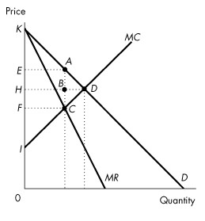
Figure 13.3.3

8) Consider the market demand curve in Figure 13.3.3. If the market is perfectly competitive, which area indicates consumer surplus?
A) AEK
B) DHK
C) DIK
D) DIH
E) None of the above.
Answer: B
Diff: 3 Type: MC
Topic: Single-Price Monopoly and Competition Compared
Source: Study Guide
9) Consider the market demand curve in Figure 13.3.3. If the market is perfectly competitive, which area indicates producer surplus?
A) AEK
B) DHK
C) DIK
D) DIH
E) None of the above.
Answer: D
Diff: 3 Type: MC
Topic: Single-Price Monopoly and Competition Compared
Source: Study Guide

10) Consider the market demand curve in Figure 13.3.3. If the market is perfectly competitive, which area indicates the deadweight loss?
A) ABD
B) BCD
C) KDI
D) ADC
E) None of the above.
Answer: E
Diff: 3 Type: MC
Topic: Single-Price Monopoly and Competition Compared

11) Consider the revenue and cost curves in Figure 13.3.3. If this is a single-price monopoly, what is consumer surplus?
A) EADH
B) EABH
C) ABD
D) ACD
E) KEA
Answer: E
Diff: 3 Type: MC
Topic: Single-Price Monopoly and Competition Compared

12) Consider the revenue and cost curves in Figure 13.3.3. What is the difference in consumer surplus between a single-price monopoly and a perfectly competitive market?
A) EADH
B) EABH
C) ABD
D) ACD
E) FHDC
Answer: A
Diff: 3 Type: MC
Topic: Single-Price Monopoly and Competition Compared
13) Consider the revenue and cost curves in Figure 13.3.3. If this is a single-price monopoly, what area is producer surplus?
A) IHD
B) KHD
C) KEA
D) IEAC
E) None of the above.
Answer: D
Diff: 3 Type: MC
Topic: Single-Price Monopoly and Competition Compared

14) Consider the revenue and cost curves in Figure 13.3.3. What is the difference in producer surplus between a single-price monopoly and a perfectly competitive market?
A) EADH
B) EABH
C) ABD
D) ACD
E) EABH - BCD
Answer: E
Diff: 3 Type: MC
Topic: Single-Price Monopoly and Competition Compared

15) Refer to Figure 13.3.3. What is the redistribution of surplus from consumers to the producer with a single-price monopoly, as compared to a perfectly competitive market?
A) EADH
B) EABH
C) ABD
D) ACD
E) EABH - BCD
Answer: B
Diff: 3 Type: MC
Topic: Single-Price Monopoly and Competition Compared

16) Consider the cost and revenue curves in Figure 13.3.3. Which area indicates the deadweight loss from a single-price monopoly?
A) EACF
B) ACD
C) ABD
D) BCD
E) None of the above.
Answer: B
Diff: 3 Type: MC
Topic: Single-Price Monopoly and Competition Compared
Source: Study Guide
17) Rent seeking ________.
A) is a variable cost and with rent seeking the monopoly becomes more efficient
B) decreases average total cost and with rent seeking the monopoly becomes more efficient
C) increases deadweight loss above the original monopoly deadweight loss, but the monopoly continues to produce the same inefficient quantity
D) decreases consumer surplus and with rent seeking the monopoly becomes more efficient
E) decreases deadweight loss
Answer: C
Diff: 3 Type: MC
Topic: Single-Price Monopoly and Competition Compared
Source: MyEconLab

18) Consumer surplus is
A) positive in the case of a monopolist practising perfect price discrimination.
B) equal to price minus marginal cost.
C) less in the case of a single-price monopoly than in the case of a perfectly competitive industry.
D) zero for a single-price monopolist.
E) greater in a single-price monopoly than in a perfectly competitive industry.
Answer: C
Type: MC
Topic: Single-Price Monopoly and Competition Compared
Skill: Recognition
AACSB: Reflective Thinking

19) The creation of a monopoly results in gains to
A) producers at no expense to consumers.
B) consumers at no expense to producers.
C) producers at the expense of consumers.
D) consumers at the expense of producers.
E) producers and consumers at the expense of the government.
Answer: C
Type: MC
Topic: Single-Price Monopoly and Competition Compared
Skill: Conceptual
AACSB: Reflective Thinking

20) Rent seeking is best defined as
A) an attempt by landlords to get tenants.
B) the pursuit of wealth by capturing economic rent.
C) an attempt by individuals to avoid paying taxes.
D) owners of a monopoly selling the firm at the highest possible price.
E) none of the above.
Answer: B
Type: MC
Topic: Single-Price Monopoly and Competition Compared
Skill: Recognition
AACSB: Reflective Thinking
21) Methods of rent seeking include which of the following?
I. Buying a monopoly
II. Creating a monopoly
III. Price discrimination
A) I and II
B) I and III
C) II and III
D) III only
E) II only
Answer: A
Type: MC
Topic: Single-Price Monopoly and Competition Compared
Skill: Recognition
AACSB: Reflective Thinking

22) Which one of the following is true for a single-price monopolist but not for a perfectly competitive firm?
A) The firm maximizes profit by setting marginal cost equal to marginal revenue.
B) The firm is a price-taker.
C) The firm can sell any level of output at any price it sets.
D) The firm's marginal cost is less than price.
E) The firm's marginal revenue curve is horizontal.
Answer: D
Diff: 2 Type: MC
Topic: Single-Price Monopoly and Competition Compared
Use the figure below to answer the following questions.

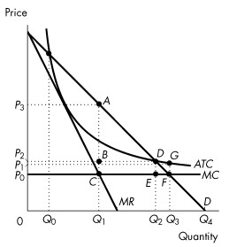
Figure 13.3.4

23) Consider the natural monopoly depicted in Figure 13.3.4. Total surplus is at a maximum when quantity is
A) Q1 and price is P1.
B) Q1 and price is P3.
C) Q2 and price is P2.
D) Q3 and price is P0.
E) Q4 and price is 0.
Answer: D
Diff: 3 Type: MC
Topic: Single-Price Monopoly and Competition Compared

24) Consider the natural monopoly depicted in Figure 13.3.4. What area in the graph represents the deadweight loss arising from an unregulated monopoly?
A) ABD
B) DGF
C) DEF
D) ACF
E) CBDE
Answer: D
Diff: 3 Type: MC
Topic: Single-Price Monopoly and Competition Compared
25) One difference between perfectly competitive markets and a single-price monopoly is that
A) marginal revenue equals marginal cost for perfectly competitive firms, but not for single-price monopolists.
B) marginal cost equals average variable cost for perfectly competitive firms but not for single-price monopolists.
C) price equals minimum average total cost for single-price monopolists but not for perfectly competitive firms.
D) marginal revenue equals price for perfectly competitive firms, but not for single-price monopolists.
E) none of the above
Answer: D
Type: MC

26) Which of the following markets will have the largest deadweight loss?
A) a single-price monopoly
B) a perfectly competitive market
C) a perfectly price discriminating monopoly
D) both B and C
E) both A and C
Answer: A
Type: MC
13.4 Price Discrimination

Use the figure below to answer the following question.
Figure 13.4.1

1) Which area in Figure 13.4.1 indicates the deadweight loss from a perfect price-discriminating monopoly?
A) EACF
B) ACD
C) ABD
D) BCD
E) None of the above.
Answer: E
Diff: 3 Type: MC
Topic: Price Discrimination
Source: Study Guide

2) When perfect price discrimination occurs, which one of the following statements is false ?
A) Buyers cannot resell the product.
B) The firm can distinguish between buyers.
C) The firm sets prices.
D) The firm captures consumer surplus.
E) The outcome is less efficient than with single-price monopoly.
Answer: E
Diff: 3 Type: MC
Topic: Price Discrimination
Source: Study Guide
3) A monopoly can practise price discrimination when it
A) can segment the market according to the different prices the consumers are willing to pay.
B) is a price taker.
C) has different marginal costs of production for different output levels.
D) has decreasing average variables cost.
E) produces a good with close substitutes.
Answer: A
Diff: 2 Type: MC
Topic: Price Discrimination

Use the figure below to answer the following question.

Figure 13.4.2

4) Refer to Figure 13.4.2. Assume this monopolist practises perfect price discrimination. This means that
A) the monopoly's behaviour is illegal.
B) one price is charged to young people and a different price to older people.
C) a different price can be charged to each buyer.
D) price will rise as the number of buyers increases.
E) the quantity sold will be less compared to the case of no price discrimination.
Answer: C
Diff: 2 Type: MC
Topic: Price Discrimination
5) Refer to Figure 13.4.2. Assume this monopolist practises perfect price discrimination. What is the lowest price charged for tickets?
A) $0
B) $1.00
C) $3.50
D) $3.00
E) $2.00
Answer: E
Diff: 3 Type: MC
Topic: Price Discrimination

6) Refer to Figure 13.4.2. Assume this monopolist practises perfect price discrimination. How many tickets are sold?
A) 20 tickets
B) 60 tickets
C) 40 tickets
D) 100 tickets
E) 80 tickets
Answer: B
Diff: 3 Type: MC
Topic: Price Discrimination

7) Refer to Figure 13.4.2. Assume this monopolist practises perfect price discrimination. What is total revenue?
A) $110
B) $210
C) $310
D) $120
E) $105
Answer: B
Diff: 3 Type: MC
Topic: Price Discrimination

8) If a firm practises perfect price discrimination,
A) its marginal cost curve is horizontal.
B) it will maximize total revenue.
C) it does not produce the quantity at which marginal revenue equals marginal cost.
D) it will produce the quantity at which the marginal revenue curve intersects the average total cost curve.
E) it will produce the quantity at which the marginal cost curve intersects the demand curve.
Answer: E
Diff: 3 Type: MC
Topic: Price Discrimination
Use the table below to answer the following questions.

Table 13.4.1

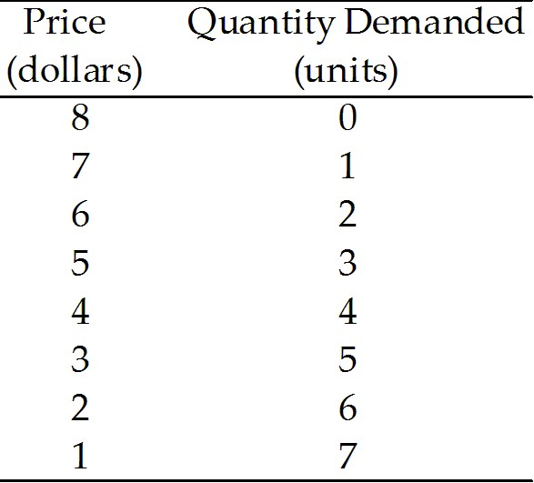

9) Refer to Table 13.4.1. If a perfect price-discriminating monopoly faces the demand schedule shown in Table 13.4.1 and if marginal cost is constant at $3, output is
A) 2 units.
B) 3 units.
C) 4 units.
D) 5 units.
E) 6 units.
Answer: D
Diff: 3 Type: MC
Topic: Price Discrimination

10) Table 13.4.1 shows the demand schedule faced by a monopoly. If the monopoly is a perfect price-discriminating monopoly the marginal revenue from the sale of the 3rd unit of output is
A) $2.
B) $6.
C) $4.
D) $3.
E) $5.
Answer: E
Diff: 3 Type: MC
Topic: Price Discrimination

11) Table 13.4.1 shows the demand schedule faced by a perfect price-discriminating monopoly. If 3 units are sold, total revenue is
A) $15.00.
B) $16.00.
C) $18.00.
D) $19.50.
E) $5.00.
Answer: C
Diff: 3 Type: MC
Topic: Price Discrimination
12) The output of a (not perfect) price-discriminating monopoly is
A) less than a single-price monopoly.
B) more than a single-price monopoly but less than a perfectly competitive industry.
C) the same amount as a perfectly competitive industry.
D) more than a perfectly competitive industry.
E) less than a single-price monopoly but more than a perfectly competitive industry.
Answer: B
Diff: 2 Type: MC
Topic: Price Discrimination
Source: Study Guide

13) A perfect price-discriminating monopoly produces
A) less than a single-price monopoly.
B) more than a single-price monopoly but less than a perfectly competitive industry.
C) less than a monopoly that practices price discrimination but not perfect price discrimination.
D) more than a perfectly competitive industry.
E) the same amount as a perfectly competitive industry.
Answer: E
Diff: 2 Type: MC
Topic: Price Discrimination

14) A perfect price-discriminating monopoly
A) has a demand curve that is also its marginal revenue curve.
B) maximizes total revenue.
C) is inefficient.
D) will produce the quantity at which the marginal cost curve intersects its demand curve.
E) both A & D are correct.
Answer: E
Diff: 3 Type: MC
Topic: Price Discrimination
Source: Study Guide

15) Which of the following quotes by a store manager describes price discrimination in action?
A) "Since bulk goods are cheaper to package, I can offer a lower price."
B) "I can get a 4-litre jug of milk from the supplier for less than four 1-litre cartons, so I can sell it for less per litre."
C) "We offer our employees a 10 percent price discount."
D) "I offer discounts if you buy 12 apple juices in one box, although it costs me the same as if I split it up and sell them separately."
E) "We set price equal to average variable cost."
Answer: D
Diff: 2 Type: MC
Topic: Price Discrimination
Use the figure below to answer the following question.

Figure 13.4.3

16) Refer to Figure 13.4.3. The outcome is efficient if
A) the monopoly is able to perfectly price discriminate.
B) the price consumers pay is equal to average total cost.
C) the price consumers pay exceeds minimum average variable cost.
D) the quantity produced is 80 units.
E) the quantity produced is 20 units.
Answer: A
Diff: 2 Type: MC
Topic: Price Discrimination

17) A perfect price-discriminating monopoly is
A) less efficient than a single-price monopoly.
B) more efficient than a single-price monopoly, but less efficient than a perfectly competitive industry.
C) as efficient as a single-price monopoly.
D) more efficient than a perfectly competitive industry.
E) as efficient as a perfectly competitive industry.
Answer: E
Diff: 3 Type: MC
Topic: Price Discrimination
Use the figure below to answer the following questions.

Figure 13.4.4

18) Refer to Figure 13.4.4. Consider a market with a monopoly that distinguishes between two groups of buyers. If the light grey area shows the consumer surplus and the dark grey area shows the producer surplus, which graphs correctly represents this firm?
A) (a)
B) (b)
C) (c)
D) (d)
E) (b) and (d)
Answer: C
Diff: 3 Type: MC
Topic: Price Discrimination

19) Refer to Figure 13.4.4. Consider a market with a perfect price-discriminating monopolist. If the light grey area shows the consumer surplus and the dark grey area shows the producer surplus, which graph correctly represents this firm?
A) (a)
B) (b)
C) (c)
D) (d)
E) none of the graphs
Answer: D
Diff: 3 Type: MC
Topic: Price Discrimination
Use the figure below to answer the following questions.

Figure 13.4.5

20) Consider the cost and revenue curves in Figure 13.4.5. If this is a perfect price-discriminating monopoly, what is consumer surplus?
A) EADH
B) EABH
C) ABD
D) KEA
E) None of the above.
Answer: E
Diff: 3 Type: MC
Topic: Price Discrimination

21) Refer to Figure 13.4.5. What is the redistribution of surplus from consumers to the producer with a perfect price-discriminating monopoly, as compared to a perfectly competitive market?
A) EADH
B) EABH
C) ABD
D) ACD
E) KHD
Answer: E
Diff: 3 Type: MC
Topic: Price Discrimination
22) When a monopoly practices price discrimination ________.
A) it charges different prices to different consumers and transfers some of the consumer surplus to economic profit
B) it produces a smaller quantity than when it is a single-price monopoly which decreases consumer surplus
C) new firms enter the industry, so buyers have more goods from which to choose and consumer surplus increases
D) consumer surplus increases because the monopoly increases the quantity available for sale
E) firms exit the industry and consumer surplus decreases
Answer: A
Diff: 3 Type: MC
Topic: Price Discrimination
Source: MyEconLab

23) Donna owns the only dog grooming salon on Lonely Island. If Donna can price discriminate between dog owners who are seniors and those who are not, her economic profit will be ________ than if she does not price discriminate and the number of dog groomings will be ________ if she does not price discriminate.
A) greater; more than
B) greater; less than
C) less; more than
D) less; less than
E) greater; the same as
Answer: A
Type: MC
Topic: Price Discrimination
Skill: Conceptual
AACSB: Reflective Thinking

24) The more perfectly a monopoly can price discriminate, the
A) smaller its output and the lower its profit.
B) smaller its output and the higher its profit.
C) larger its output and the lower its profit.
D) larger its output and the higher its profit.
E) none of the above.
Answer: D
Type: MC
Topic: Price Discrimination
Skill: Analytical
AACSB: Reflective Thinking
25) Which of the following occurs with both perfectly price-discriminating and single-price monopolies?
A) The amount of output is inefficient.
B) All consumer surplus goes to the monopoly.
C) Deadweight loss is created.
D) There is a redistribution of consumer surplus to the monopoly.
E) Demand is perfectly elastic.
Answer: D
Type: MC
Topic: Price Discrimination
Skill: Recognition
AACSB: Reflective Thinking

26) Which of the following is true for a perfect price-discriminating monopoly?
A) P = MR for each unit sold.
B) P = ATC for each unit sold.
C) P = MC for each unit sold.
D) P > MC for each unit sold.
E) P > MR for each unit sold.
Answer: A
Type: MC
Topic: Price Discrimination
Skill: Conceptual
AACSB: Reflective Thinking

27) If a monopolist can perfectly price discriminate, then
A) price equals average cost for each unit sold.
B) price equals marginal cost for each unit sold.
C) price equals marginal cost for the last unit sold.
D) the firm can ignore the marginal cost curve.
E) price is greater than marginal revenue for each unit sold.
Answer: C
Type: MC
Topic: Price Discrimination
Skill: Conceptual
AACSB: Reflective Thinking

28) For a monopoly able to practice perfect price discrimination, the market
A) supply curve is horizontal.
B) supply curve is the same as the marginal revenue curve.
C) demand curve is the same as the marginal cost curve.
D) demand curve is the same as the marginal revenue curve.
E) demand curve is horizontal.
Answer: D
Type: MC
Topic: Price Discrimination
Skill: Conceptual
AACSB: Reflective Thinking
Use the figure below to answer the following questions.

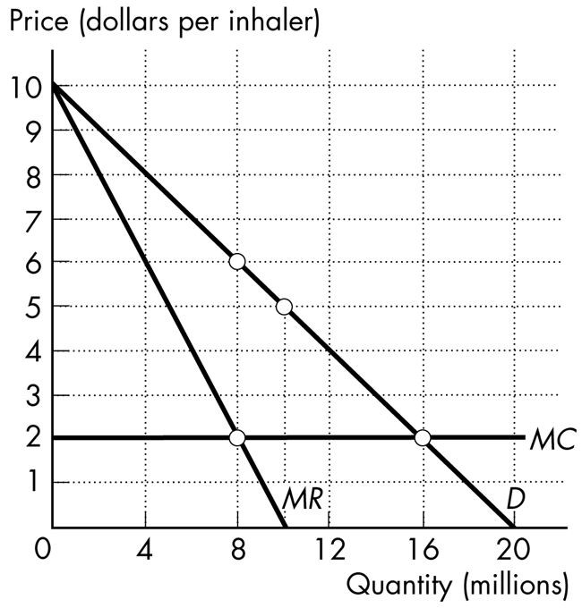

Figure 13.4.6

29) Prime Pharmaceuticals has developed a new asthma medicine, for which it has a patent. An inhaler can be produced at a constant marginal cost of $2 per inhaler. The demand curve, marginal revenue curve, and marginal cost curve for this new asthma inhaler are shown in Figure 13.4.6. The patent gives Prime Pharmaceuticals a monopoly for its new inhaler. If Prime Pharmaceuticals can perfectly price discriminate, then it
A) sells 16 million inhalers.
B) charges a price of $2 for each inhaler it sells.
C) sells inhalers for $6 each.
D) makes zero economic profit.
E) Both A and B are correct.
Answer: A
Type: MC

30) Prime Pharmaceuticals has developed a new asthma medicine, for which it has a patent. An inhaler can be produced at a constant marginal cost of $2 per inhaler. The demand curve, marginal revenue curve, and marginal cost curve for this new asthma inhaler are shown in Figure 13.4.6. The patent gives Prime Pharmaceuticals a monopoly for its new inhaler. If Prime Pharmaceuticals can perfectly price discriminate, then consumer surplus is
A) zero.
B) $24 million.
C) $64 million.
D) $44 million.
E) $32 million.
Answer: A
Type: MC
13.5 Monopoly Regulation

1) Rate of return regulation can end up serving the self-interest of the firm if
A) there is a great demand for the good.
B) there is a competitive struggle to determine which firms will supply the market.
C) the regulated firm overstates its costs of production.
D) price is set at average total cost.
E) the rate is set too low.
Answer: C
Diff: 2 Type: MC
Topic: Monopoly Regulation

2) A monopolist under rate of return regulation has an incentive to
A) pad costs.
B) produce more than the efficient quantity of output.
C) charge a price equal to marginal cost.
D) maximize consumer surplus.
E) maximize shareholder profits
Answer: A
Diff: 2 Type: MC
Topic: Monopoly Regulation
Source: Study Guide

3) A monopolist under marginal cost pricing has an incentive to
A) inflate costs.
B) produce more than the efficient quantity of output.
C) produce less than the efficient quantity of output.
D) maximize consumer surplus.
E) produce the efficient quantity of output.
Answer: E
Diff: 3 Type: MC
Topic: Monopoly Regulation
Use the information below to answer the following questions.

Fact 13.5.1

Cascade Springs Inc. is a natural monopoly that bottles water from a spring high in the Rocky Mountains. The total fixed cost it incurs is $80,000, and its marginal cost is 10 cents a bottle. The demand curve for Cascade Springs bottled water is shown in the following figure:

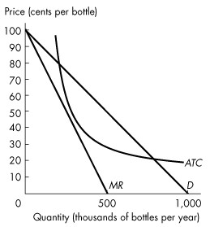
Figure 13.5.1

4) Refer to Figure 13.5.1. Suppose the industry is unregulated. In this case, output is
A) 400,000 bottles per year.
B) 450,000 bottles per year.
C) 600,000 bottles per year.
D) 700,000 bottles per year.
E) 800,000 bottles per year.
Answer: B
Diff: 2 Type: MC
Topic: Monopoly Regulation

5) Refer to Figure 13.5.1. Suppose the firm is regulated by the government that imposes marginal cost pricing. The price of a bottle of water is
A) $0.
B) $0.50.
C) $0.30.
D) $0.10.
E) $0.20.
Answer: D
Diff: 3 Type: MC
Topic: Monopoly Regulation
6) Refer to Figure 13.5.1. Suppose the government regulates the firm with average cost pricing. What is the price?
A) $0 a bottle
B) $0.50 a bottle
C) $0.30 a bottle
D) $0.10 a bottle
E) $0.20 a bottle
Answer: E
Diff: 3 Type: MC
Topic: Monopoly Regulation

Use the figure below to answer the following questions.

Figure 13.5.2

7) Consider the natural monopoly depicted in Figure 13.5.2. If a regulator uses a marginal cost pricing rule to set price, what is the quantity produced?
A) 0
B) Q0
C) Q1
D) Q2
E) Q3
Answer: E
Diff: 3 Type: MC
Topic: Monopoly Regulation
8) Consider the natural monopoly depicted in Figure 13.5.2. If a regulatory agency sets a price just sufficient for the firm to make zero economic profit, what output will it produce?
A) Q4
B) Q0
C) Q1
D) Q2
E) Q3
Answer: D
Diff: 2 Type: MC
Topic: Monopoly Regulation

9) Consider the natural monopoly depicted in Figure 13.5.2. If a regulatory agency sets a price just sufficient for the firm to make zero economic profit, and if the firm inflates its costs as much as possible, the regulated price will be
A) P0.
B) P1.
C) P2.
D) P3.
E) none of the above.
Answer: D
Diff: 3 Type: MC
Topic: Monopoly Regulation

10) Consider the natural monopoly depicted in Figure 13.5.2. What area in the graph represents the deadweight loss arising from an average cost pricing rule?
A) ABD
B) DGF
C) DEF
D) ACF
E) CBDE
Answer: C
Diff: 3 Type: MC
Topic: Monopoly Regulation

11) For the regulated natural monopoly, an average cost pricing rule sets price equal to
A) marginal cost.
B) total fixed cost.
C) average variable cost.
D) average fixed cost.
E) average total cost.
Answer: E
Diff: 2 Type: MC
Topic: Monopoly Regulation
12) A price cap is a price ________. A price cap might be a more effective way of regulating monopoly than rate of return regulation because under rate of return regulation ________.
A) ceiling; a firm incurs an economic loss
B) floor; price is set equal to marginal cost
C) ceiling; the firm's managers have an incentive to inflate costs
D) floor; the firm's managers have an incentive to purchase more than the efficient quantity of capital
E) floor; the firm's managers have an incentive to inflate costs
Answer: C
Diff: 2 Type: MC
Topic: Monopoly Regulation
Source: MyEconLab

13) An average cost pricing rule sets ________ equal to average total cost. An average cost pricing rule is not an efficient way of regulating monopoly because at the quantity produced ________.
A) price; marginal benefit exceeds marginal cost
B) the return on capital; marginal benefit exceeds marginal cost
C) marginal cost; marginal cost exceeds marginal benefit
D) price equal to marginal revenue, which in long-run equilibrium is; marginal cost exceeds marginal benefit
E) marginal cost; marginal benefit exceeds marginal cost
Answer: A
Diff: 2 Type: MC
Topic: Monopoly Regulation
Source: MyEconLab

14) Social interest theory predicts that the political process will seek to minimize
A) producer surplus.
B) consumer surplus.
C) total surplus.
D) deadweight loss.
E) average total cost.
Answer: D
Type: MC
Topic: Monopoly Regulation
Skill: Analytical
AACSB: Reflective Thinking

15) The capture theory holds that regulations are supplied to maximize ________.
A) total sales
B) economic profit
C) marginal product
D) consumer surplus
E) marginal revenue
Answer: B
Type: MC
Topic: Monopoly Regulation
Skill: Recognition
AACSB: Reflective Thinking
16) Under a marginal cost pricing rule, a regulated natural monopoly
A) makes an economic profit and a deadweight loss arises.
B) makes an economic profit with no deadweight loss.
C) incurs an economic loss with no deadweight loss.
D) incurs an economic loss and a deadweight loss arises.
E) breaks even.
Answer: C
Type: MC

17) Regulation of a natural monopoly will maximize the sum of consumer surplus and producer surplus if the firm is regulated with
A) an average cost pricing rule.
B) a rate of return regulation.
C) a price cap.
D) capture theory.
E) a marginal cost pricing rule.
Answer: E
Type: MC

